**Error Handling, Projects, and Libraries**

1. You will be provided with a VI (Synchronous PSRR.vi) that simulates communication with a Synchronous PSRR meter. It will have one input – Error In. If Error In has no errors, it will communicate with the device, measure PSRR and provide the output. The VI generates errors for different hardware problems detected. These can be classified as:
   1. Critical Errors – Will contain the Keyword *Critical* in the error description
   2. Passive Errors – Errors without *Critical* mentioned anywhere in the description
   3. Warnings
   4. Unknown Errors - Errors and warnings with no description (Call chain may be displayed)

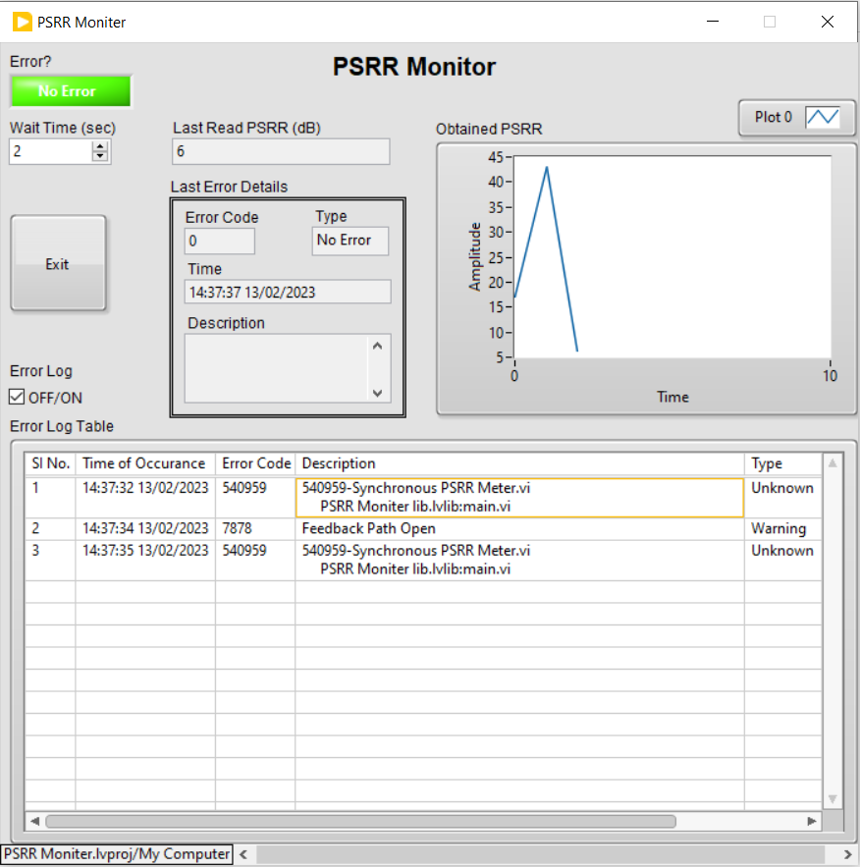EXIT

Construct a VI (as shown in the figure above). For every time interval of n second, where n is the Wait Time in seconds (not less than 2 seconds), the VI must call Synchronous PSRR.vi. If there are no errors, the obtained data must be plotted in a chart as shown.

**Error Log - If Error Log is enabled, log entry into the Error Log Table (for both error and warning).**

**Last Error Details** – Should be updated with the details of Last Error or Warning that happened.

**Error?** - In case of an error, Error? LED should be on until the error is cleared.

In case of a warning, Error? LED should be on and the Boolean text must be changed from “Error” to “Warning!”

Handle the different errors as follows:

1. **Critical Errors:** 
   1. Popup a dialog asking the user to either continue execution or abort execution. Act according to the user’s input.
   2. Do not log PSRR value in the graph. Clear the graph.
   3. The error description logged should not include call chain.
2. **Passive Errors:**
3. Log the data in the graph.
4. The error description should not include the call chain.
5. Start counting the number of occurrences of this error. On the third time a passive error happens, pop a dialog and get the user’s input as above. If the user chooses to continue, reset the counter to 0.
6. **Warnings:**
7. Update the table and the Last Error Details.
8. Log PSRR data in the graph.
9. The error description should not include the call chain.
10. **Unknown Errors and Warnings:**
11. Update the last Error Details.
12. Update the table with the Description column as <Error Code> - <VI where Error Happened>.
13. Do not log data into the graph.
14. If three occurrences happen, display the call chain of the last error in a separate popup and wait for user input on how to proceed.

|  |  |  |
| --- | --- | --- |
| **Input/Output** | **Label** | **Datatype** |
| Input | Wait Time (sec) | Numeric |
| Input | Exit | Boolean |
| Input | Error Log | Boolean |
| Output | Last Read PSRR (dB) | Numeric |
| Output | Error Code | Numeric |
| Output | Type | String |
| Output | Time | String |
| Output | Description | String |
| Output | Error? | Boolean |
| Output | Error String | String |
| Output | Obtained PSRR | Chart |
| Output | Error Log Table | Table |

**Application Builder:**

* Create an EXE for the above solution with the name “PSRR Monitor.exe”.
* Create an installer that will install the created EXE in the location “C:\Program Files\Soliton\PSRR Monitor.exe”